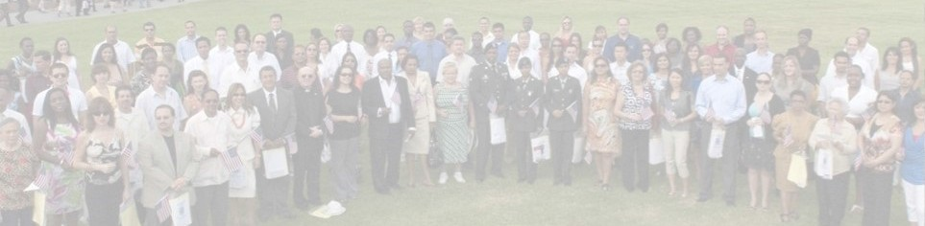

FREE CITIZENSHIP WORKSHOP

Edenvale Community Center
330 Branham Lane, San Jose, CA 95111

March 18, 2017 8:30 – 11:30 AM

Citizenship may be easier and more important than you think.

LEARN
TAKE HOME
GET HELP
- the requirements and process

- the USCIS citizenship interview questions
- ESL and language referrals
- completing your citizenship application
- requesting a fee waiver

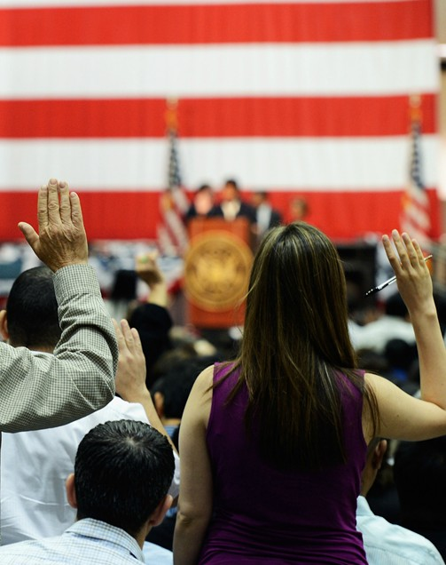
Apply At The Workshop
WHAT YOU NEED:
- Be at least 18 years old.
- Be a legal permanent resident for 5 years, or 3 years if married to U.S. citizen.
- Your green card and social security card.
- Your address and job history for the last 5 years.
- List of ALL trips taken outside of the U.S. for the last 5 years.
- Family information for ALL children and spouses (current and former).
- If you have ever been arrested, certificates of disposition for all arrests.
TO APPLY FOR A FEE WAIVER:
- 2016 Income Tax or Proof of Public Benefits (Medi-Cal, CalFresh, WIC, CalWORKS , General Assistance, Cash Aid, SSI)
* if you do not qualify for the fee waiver, the USCIS fee is $680, payable to “U.S. Department of Homeland Security” via credit card, check or money order
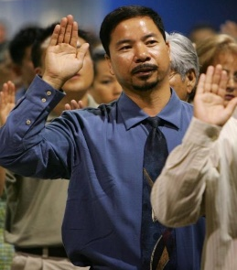
Citizenship gives you a voice and a vote, freedom to travel wherever, whenever, and more power to bring your family together and keep them together in the United States.

For more information: e-immigrate.us | To register: 408.217.0233

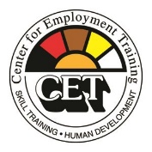

Office of Immigrant Affairs

